FOR IMMEDIATE RELEASE

Contact: Shields B. Howard
Development & Marketing Manager
Hospice of Stanly & the Uwharrie
704-983-4216 ext. 114
showard@hospiceofstanly.org

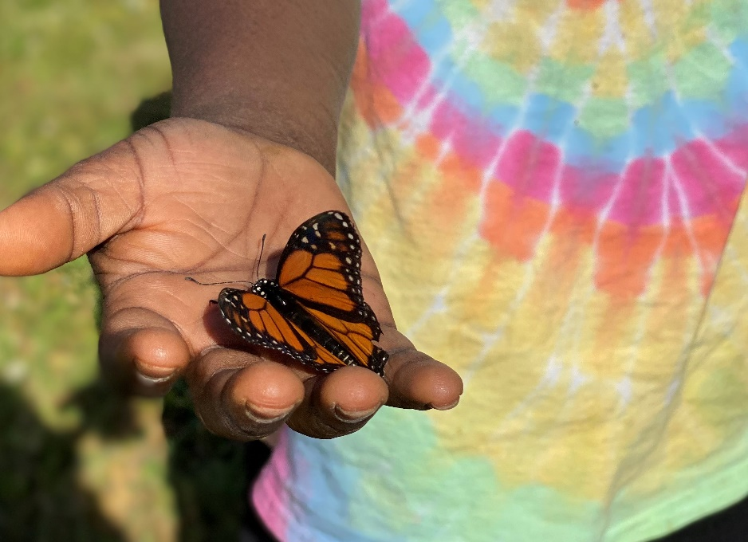

Hospice of Stanly & the Uwharrie Host Day Camp for Children and their Families

May 27, 2021 (ALBEMARLE, NC) – Hospice of Stanly & the Uwharrie recently hosted a day camp for children and their families who have experienced a death-related loss. Camp Forget-Me-Not was held on Saturday, May 1 at Camp Joshua. The theme for the event was Giving Hope Wings and featured a butterfly release.

“Our team at Hospice of Stanly & the Uwharrie always looks forward to this event”, said Bereavement Coordinator Michaele Conners, MA, LCMHC. “Our goal is to provide a safe and supportive environment for grieving children and their families. We offer a therapeutic experience through fun activities like fishing, horseback riding, crafts, a scavenger hunt, and, of course, the butterfly release.”

The event registration, all meals, and supplies are provided at no charge to the campers. Camp Forget-Me-Not is open to any children ages 6-17 and their families in the area who have experienced a death, even if the death was not hospice related. The event was sponsored by the United Way of Stanly County.

“Many thanks to the United Way of Stanly County and the hospice volunteers,” said Janna Spurr, MSW, LCSW. “This camp gives children the opportunity to grieve and to explore their feelings in a safe environment where they can both give and receive support from their peers.”

If you would like more information about bereavement counseling or to make a donation to Hospice of Stanly & the Uwharrie, please visit hospiceofstanly.org or call 704.983.4216.

About Hospice of Stanly & the Uwharrie
Hospice of Stanly & the Uwharrie, a nonprofit organization, was founded through the grassroots efforts of people in the community and it continues to be governed locally by a board of directors. Through the generosity of many, Hospice of Stanly has been able to provide care to more than 6,600 terminally ill residents since 1981. The organization provides compassionate care, comfort, and support for patients and their families. More information about hospice and advance care planning is available from Hospice of Stanly & the Uwharrie by calling 704-983-4216 or by visiting hospiceofstanly.org.

###

