FOR IMMEDIATE RELEASE

Contact: Shields B. Howard
Development & Marketing Manager
Hospice of Stanly & the Uwharrie
704.983.4216 ext. 114
showard@hospiceofstanly.org

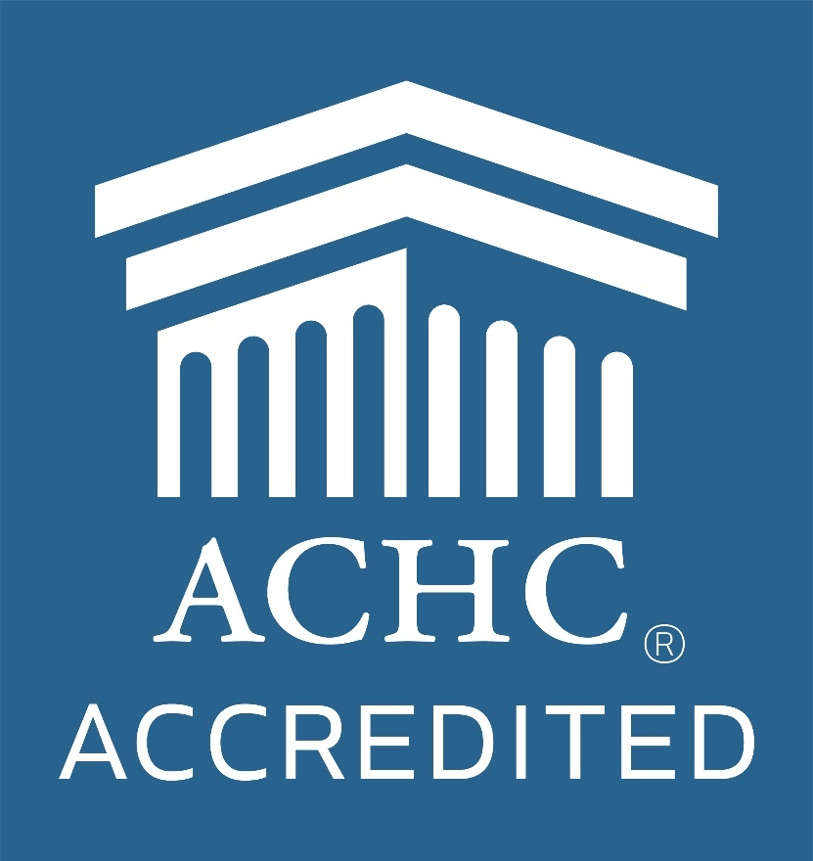

Hospice of Stanly & the Uwharrie Achieves Accreditation

July 9, 2021 (ALBEMARLE, NC) -- Hospice of Stanly & the Uwharrie announces it has achieved accreditation through the Accreditation Commission for Health Care (ACHC).

Accreditation is a process through which healthcare organizations demonstrate compliance with national standards. This process by ACHC reflects an organization’s dedication and commitment to meeting standards that facilitate a higher level of performance and patient care.

ACHC is a nonprofit organization that has stood as a symbol of quality and excellence since 1986. ACHC is certified and has CMS deeming authority for Home Health, Hospice, and DMEPOS.

Hospice of Stanly and the Uwharrie has been honored to serve terminally ill patients since its founding in 1981. Hospice care focuses on the quality of life and uses an interdisciplinary team approach with their patients and families. The hospice care team provides a range of family services to promote increased comfort levels for patients and support to caregivers, including medical consultation, skilled nursing care, pain and symptom management, hospice aide services, coordination and delivery of medical equipment, counseling, and emotional / spiritual support.

“This accreditation serves to validate the incredible compassion of our team and their steadfast commitment to quality care,” said Executive Director Lori Thayer. “We are pleased to offer our patients and their families the highest standard of care available.”

If you would like more information about our services or would like to make a donation to Hospice of Stanly & the Uwharrie, please visit hospiceofstanly.org or call 704.983.4216.

About Hospice of Stanly & the Uwharrie
Hospice of Stanly & the Uwharrie, a nonprofit organization, was founded through the grassroots efforts of people in the community and it continues to be governed locally by a board of directors. Through the generosity of many, Hospice of Stanly has been able to provide care to more than 6,600 terminally ill residents since 1981. The organization provides compassionate care, comfort, and support for patients and their families. More information about hospice and advance care planning is available from Hospice of Stanly & the Uwharrie by calling 704.983.4216 or by visiting hospiceofstanly.org.

###

