FOR IMMEDIATE RELEASE

Contact: Shields B. Howard
Development & Marketing Manager
Hospice of Stanly & the Uwharrie
704.983.4216 ext. 114
showard@hospiceofstanly.org

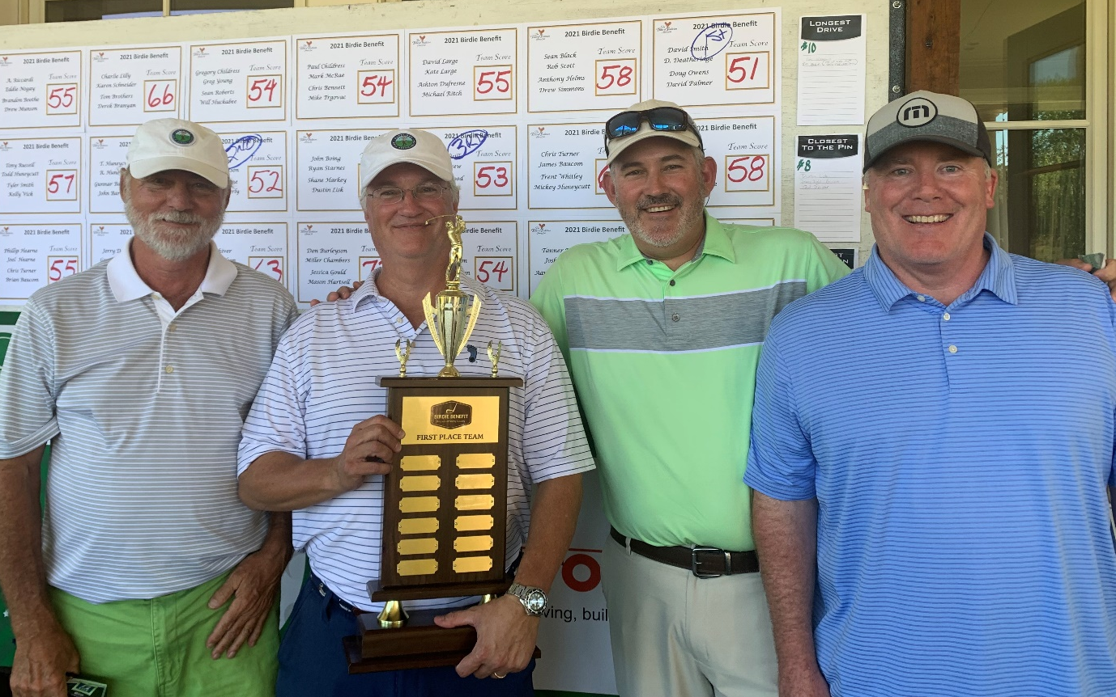
Pinnacle Financial Partners took home the 1st place trophy at the Hospice of Stanly golf tournament
Hospice of Stanly Hosts
17th Annual Golf Tournament

October 21, 2021 (ALBEMARLE, NC) -- Hospice of Stanly & the Uwharrie recently hosted the 17th annual golf tournament at The Tillery Tradition Country Club. The event included 18 holes of golf, contests, prizes, a raffle, and great food. Proceeds will benefit Hospice of Stanly & the Uwharrrie.

A team from Pinnacle Financial Partners in Albemarle was the first-place team. The team from Clint Miller Exterminating scored second place, while Uwharrie Bank was the third-place team. The field was quite competitive as 22 teams competed in the tournament.

Pinnacle Financial Partners Senior Vice President David Smith said, “Pinnacle Bank was very proud to support Hospice of Stanly and the care they provide here in the community.”

The event raised nearly $32,000 for the organization. Executive Director Lori Thayer said, “We certainly thank our participants and sponsors for their support. The income from our fundraising events is used to support our programs that deliver quality care for our patients and their families.”

Event sponsors include Team Large, Fiberon, and First Bank Insurance Services. The Putting Contest was sponsored by Uwharrie Bank; the Water Bottle sponsor was Pinnacle Financial Partners; Stanly Funeral and Cremation Care and First Bank were the Longest Drive Contest sponsors; BRS was the Hat sponsor; Kelly Office Solutions and Badin Brews sponsored the Beverage Cart; Friendly Chevrolet-Buick was the sponsor for the Closest-to-the-Pin Contest; Whispering Pines Barbecue provided lunch; Biscuitville provided breakfast; and Kayren Brantley was the Raffle sponsor.

Hole sponsors included 110 Main Mercantile of Norwood; Ballard Heating & Cooling; Cache Noir, Cadillac Sign Co; Clint Miller Exterminating; Dogwood Farms NC; Econo Oil of Troy; Efird’s Insulating Co; Entrance Masters Garage Door & Gate Co; FSIoffice; First United Methodist Church of Troy; H.W. Culp Lumber Co; Hudson Property Services; Hudson Pool Distributors; Lou Page; M & R Retreading & Oil Co; Mauney Feed Mill, McRae Industries; Medical Pharmacy of Albemarle; Patricia & Bill Mullinix Jr; Reservoir Coffee of Norwood; Rocky River Pest Control; Stokes Contruction Company; Stony Mountain Vineyards; Strong Forestry; Tarheel Auto Sales; Thayer’s Automotive; Wise Management Solutions; J.T. Russell & Sons; Whitley Realty;

About Hospice of Stanly & the Uwharrie
Hospice of Stanly & the Uwharrie, a nonprofit organization, was founded through the grassroots efforts of people in the community and it continues to be governed locally by a board of directors. Through the generosity of many, Hospice of Stanly has been able to provide care to more than 6,700 terminally ill residents since 1981. The organization provides compassionate care, comfort, and support for patients and their families. More information about hospice and advance care planning is available from Hospice of Stanly & the Uwharrie by calling 704.983.4216 or by visiting hospiceofstanly.org.

###

