FOR IMMEDIATE RELEASE

Contact: Shields B. Howard
Development & Marketing Manager
Hospice of Stanly & the Uwharrie
704.983.4216 ext. 114
showard@hospiceofstanly.org

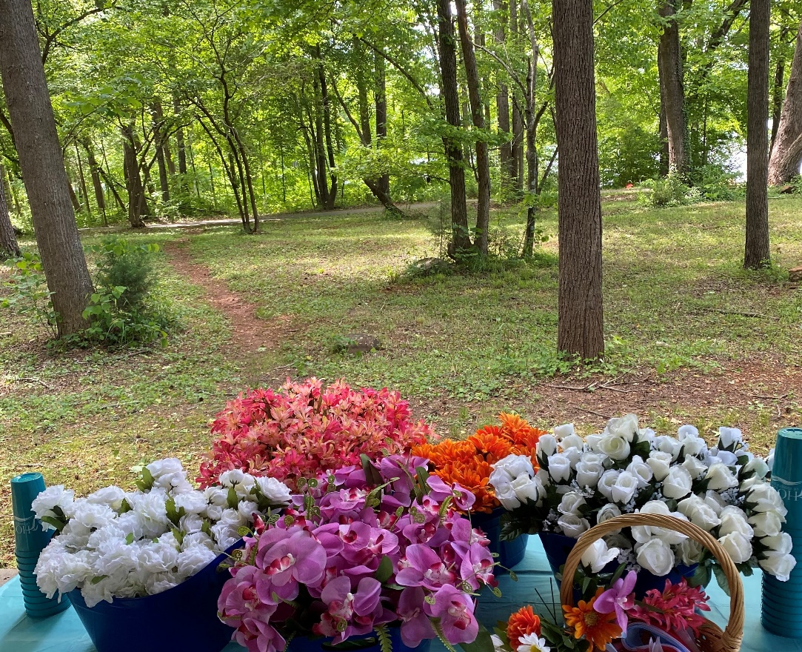
Hope Blooms 2021

Hospice of Stanly Announces Hope Blooms Event

March 16, 2022 (ALBEMARLE, NC) -- Hospice of Stanly announces the annual Hope Blooms event for anyone in the community who has experienced a loss. The grief walk will be held as a drop-in event on Thursday, April 14 anytime from 4:00 pm to 6:00 pm at City Lake Park in Albemarle.

Hope Blooms is a reflective, peaceful walk on a handicapped-accessible path. Small groups or individuals are encouraged to walk the path in quiet reflection as they pause and listen to 7 readings on grief. At each stop, a flower is presented along with a meaningful message related to the grief journey.

“Hospice of Stanly has been honored to host this event for many years,” said Hospice of Stanly Bereavement Coordinator Michaele Conners, MA, LCMHCS. “All are welcome as we help our community find meaning and understanding in their grief journey.”

The event is made possible by funding from the Stanly County United Way and the generosity of donors in the community. For questions about Hope Blooms, please contact Hospice of Stanly at 704.983.4216.

About Hospice of Stanly & the Uwharrie
Hospice of Stanly & the Uwharrie, a nonprofit organization, was founded through the grassroots efforts of people in the community and it continues to be governed locally by a board of directors. Through the generosity of many, Hospice of Stanly has been able to provide care to more than 6,800 terminally ill residents since 1981. The organization provides compassionate care, comfort, and support for patients and their families. More information about hospice and advance care planning is available from Hospice of Stanly & the Uwharrie by calling 704.983.4216 or by visiting hospiceofstanly.org.

###

