FOR IMMEDIATE RELEASE

Contact: Shields B. Howard
Development & Marketing Manager
Hospice of Stanly & the Uwharrie
704.983.4216 ext. 114
showard@hospiceofstanly.org

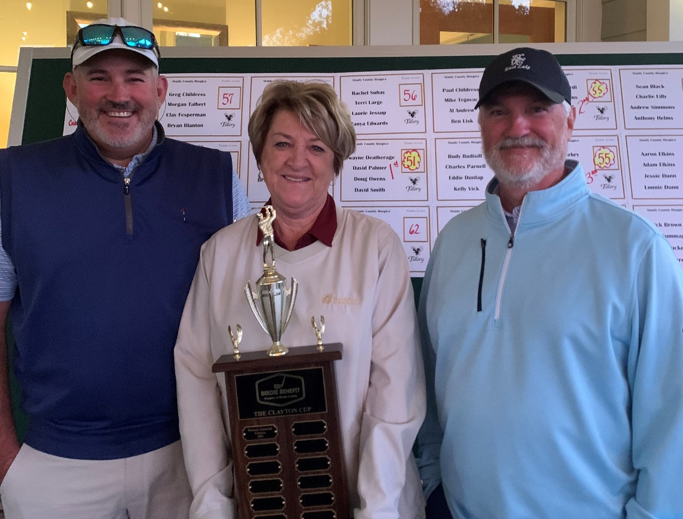
David Smith and David Palmer of Pinnacle Financial Partners took home the Clayton Cup at the Hospice of Stanly golf tournament. Hoopie Clayton presented the trophy to the winners.

Hospice of Stanly Hosts
18th Annual Golf Tournament

October 28, 2022 (ALBEMARLE, NC) -- Hospice of Stanly & the Uwharrie recently hosted the 18th annual golf tournament at The Tillery Tradition Country Club. The event included 18 holes of golf, contests, prizes, a raffle, and great food provided by Whispering Pines Barbecue. Proceeds will benefit Hospice of Stanly & the Uwharrrie.

A team from Pinnacle Financial Partners in Albemarle was the first-place team. One of the teams sponsored by Terri Large scored second place, while the team playing in memory of Dick Clayton earned a third place award. The field was quite competitive with 18 teams competing in the tournament.

Pinnacle Financial Partners Senior Vice President David Smith said, “Pinnacle Bank was very proud to support Hospice of Stanly and the care they provide here in the community.”

Executive Director Lori Thayer said, “The support we received from the golfers and the sponsors is overwhelming. We certainly thank our community for their support which enables us to deliver care and improve the quality of life of those we serve.”

About Hospice of Stanly & the Uwharrie
Hospice of Stanly & the Uwharrie, a nonprofit organization, was founded through the grassroots efforts of people in the community and it continues to be governed locally by a board of directors. Through the generosity of many, Hospice of Stanly has been able to provide care to nearly 7,000 terminally ill residents since 1981. The organization provides compassionate care, comfort, and support for patients and their families. More information about hospice and advance care planning is available from Hospice of Stanly & the Uwharrie by calling 704.983.4216 or by visiting hospiceofstanly.org.

###

